* We get it from the cdn. It’s a collection of classes.
* **We can use more than one class for an element**. Lots of use of it in application. For example -> **btn btn-primary** is the class for primary button. But we can define the size with **btn btn-primary btn-lg.**
* Overriding BootStrap

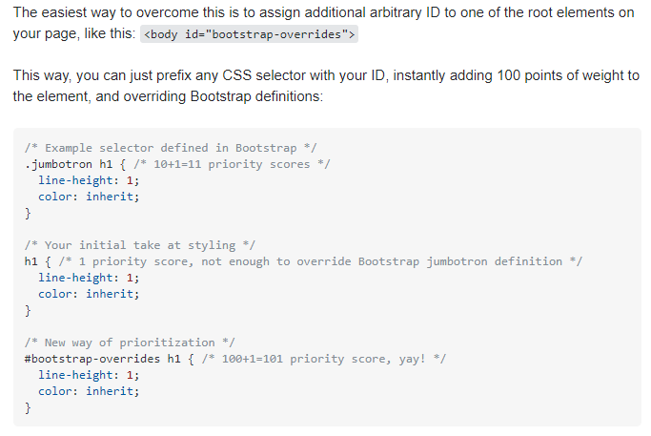

* 12 is the number of columns we can divide in bootstrap. For example, we can use 7 unit for left and 5 for right and so on. And we can Divide those units into subunit as well using the same theory. We can define its design with smaller screen as well